https://leetcode.com/problems/construct-binary-search-tree-from-preorder-traversal/
Method -1 Brute Force Approach
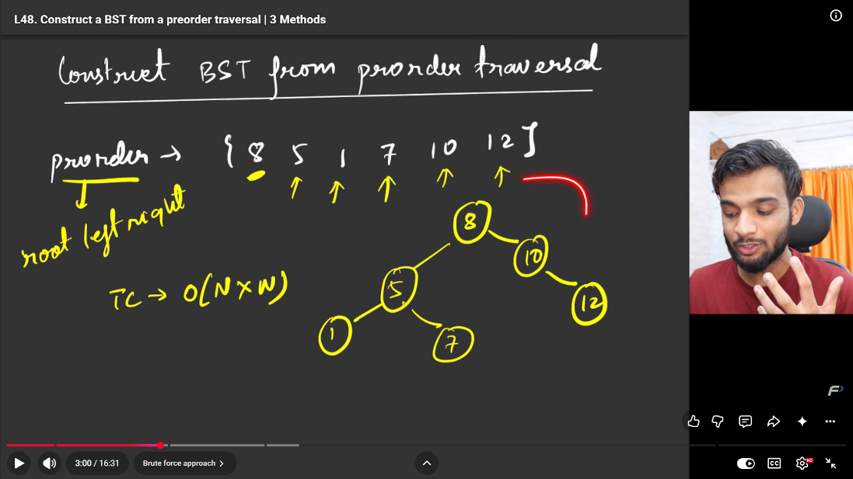
Yes. Before understanding the bound approach, it's useful to see the brute-force approach because it's much more intuitive.
For 1008. Construct Binary Search Tree from Preorder Traversal, the brute-force idea is:
Take the first element as the root, then find where the values greater than the root begin. Everything before that belongs to the left subtree, and everything after that belongs to the right subtree.

Example
preorder = [8, 5, 1, 7, 10, 12]
First element:
8
So: 8
Now scan the remaining elements and find the first value greater than 8.
5 → less than 8 → LEFT
1 → less than 8 → LEFT
7 → less than 8 → LEFT
10 → greater than 8 → RIGHT
Therefore:
left = [5, 1, 7]
right = [10, 12]
So:
8
/ \
[5,1,7] [10,12]
Then recursively do the same thing.

Java brute-force code
class TreeNode {

int val;
TreeNode left;
TreeNode right;

TreeNode(int val) {
this.val = val;
}
}

class Solution {

public TreeNode bstFromPreorder(int[] preorder) {

// Empty array
if (preorder.length == 0) {
return null;
}

// First element is root
TreeNode root = new TreeNode(preorder[0]);

// Find first element greater than root
int i = 1;

while (i < preorder.length && preorder[i] < root.val) {
i++;
}

// Elements before i belong to left subtree
int[] leftArray = new int[i - 1];

for (int j = 1; j < i; j++) {
leftArray[j - 1] = preorder[j];
}

// Elements from i onward belong to right subtree
int[] rightArray = new int[preorder.length - i];

for (int j = i; j < preorder.length; j++) {
rightArray[j - i] = preorder[j];
}

// Recursively construct both subtrees
root.left = bstFromPreorder(leftArray);
root.right = bstFromPreorder(rightArray);

return root;
}
}

Let's see what happens
For:
[8, 5, 1, 7, 10, 12]
First:
root = 8
Scan:
5 < 8
1 < 8
7 < 8
10 > 8 ← stop
So:
leftArray = [5, 1, 7]
rightArray = [10, 12]
Then recursively:
bstFromPreorder([5,1,7])
First element:
root = 5
Scan:
1 < 5
7 > 5 ← stop
Therefore:
left = [1]
right = [7]
We get:
8
/ \
5 10
/ \ \
1 7 12

Why is this brute force?
Because we're creating new arrays at every recursive call:
int[] leftArray
int[] rightArray
and repeatedly scanning/copying elements.
The bound solution avoids this.

Brute force
Find boundary
↓
Create left array
↓
Create right array
↓
Recursive calls

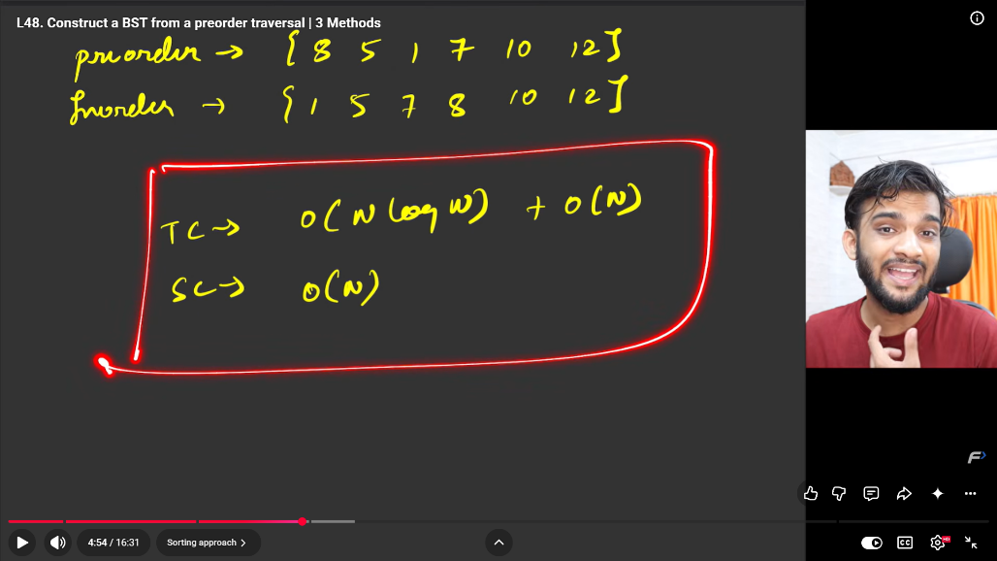
Method 2 – find inorder from preorder by sorting the preorder and then using inorder and preorder construct the bst

Method 3 – most efficient recursion approach
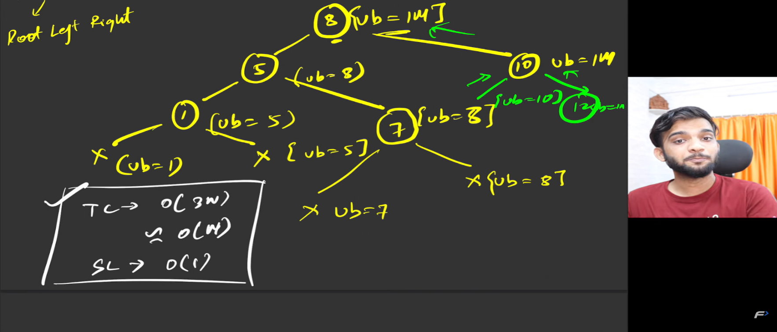
class TreeNode
{
int val;
TreeNode left;
TreeNode right;

TreeNode(int val) { this.val = val; }
}

class Solution
{
public TreeNode helper(int[] preorder, int[] i, int bound)
{
// No elements left
// OR current value is greater than the allowed bound
if (i[0] >= preorder.length || preorder[i[0]] > bound) return null;

// Create current node
TreeNode root = new TreeNode(preorder[i[0]]);

// Move to next preorder element
i[0]++;

// Construct left subtree
root.left = helper(preorder, i, root.val);

// Construct right subtree
root.right = helper(preorder, i, bound);

return root;
}

public TreeNode bstFromPreorder(int[] preorder)
{
int[] i = {0};
return helper(preorder, i, Integer.MAX_VALUE);
}
}

class Main
{
public static void main(String[] args)
{
int[] preorder = {8, 5, 1, 7, 10, 12};
Solution solution = new Solution();
TreeNode root = solution.bstFromPreorder(preorder);
System.out.println("BST constructed successfully.");
}
}

i itself is not a pointer in Java. It is a reference to an array object.
int[] i = {0};
Think of it like:
i
↓
+---+
| 0 | ← i[0]
+---+
When you do:
i[0]++;
you are not moving the pointer i.
You are changing the value stored inside the array:
Before:

i
↓
+---+
| 0 |
+---+

After i[0]++:

i
↓
+---+
| 1 |
+---+
So in this problem, you can mentally think:
i[0] acts like a pointer/index that tells us which position in the preorder array we are currently processing.
For example:
preorder = [8, 5, 1, 7, 10, 12]
↑
i[0] = 0
After processing 8:
i[0]++;
Now:
preorder = [8, 5, 1, 7, 10, 12]
↑
i[0] = 1
After processing 5:
preorder = [8, 5, 1, 7, 10, 12]
↑
i[0] = 2

Good question. This is exactly where Java arrays can be confusing.
When I said:
i = 0
I was simplifying it. Technically, i is an array, not an integer.
We wrote:
int[] i = {0};
This creates an array containing one integer:
i
↓
+-----+
| 0 |
+-----+
[0]
So:
i[0] = 0
The correct statement is:
Initially, i[0] is 0.
Not technically:
i is 0.

Why did we do this?
We need i to behave like a single changing integer that is shared among all recursive calls.
So:
int[] i = {0};
means:
i → [0]
↑
i[0]
Then:
i[0]++;
changes it:
Before:

i → [0]

After i[0]++:

i → [1]
Then:
i[0]++;
again:
i → [2]

Why not simply use int i = 0?
Because Java passes primitive int by value.
For example:
int i = 0;

helper(i);
The method gets a copy:
main's i helper's i
0 → 0
If helper does:
i++;
then:
main's i helper's i
0 1
The original i is still 0.
But with:
int[] i = {0};
both methods refer to the same array object:
┌───────┐
main ───────→│ 0 │
└───────┘
↑
helper
If helper does:
i[0]++;
the shared array changes:
┌───────┐
main ───────→│ 1 │
└───────┘
↑
helper
So when recursion continues, everyone sees:
i[0] == 1
That's why the C++:
int &i
was converted to Java:
int[] i
for this particular approach.
In short:
int[] i = {0};
means i is an array whose first (and only) element is 0.

12. Why Integer.MAX_VALUE?
We initially don't have any restriction.
The first node can be anything allowed by the problem.
So we say:
Integer.MAX_VALUE
which is:
2147483647
Therefore:
return helper(preorder, i, Integer.MAX_VALUE);
means:
Start constructing the tree, and initially allow any integer value.
Later, the bound becomes smaller depending on where we are.

13. Let's dry run it
Input:
[8, 5, 1, 7, 10, 12]
Initially:
i = 0
bound = 2147483647

Step 1
Current:
preorder[0] = 8
Create:
8
Increment:
i = 1
Now:
root.left = helper(..., bound = 8)

Step 2
Current:
preorder[1] = 5
5 <= 8, so allowed.
Create:
8
/
5
Increment:
i = 2
Now build left of 5:
bound = 5

Step 3
Current:
preorder[2] = 1
Check:
1 > 5
False.
Create:
8
/
5
/
1
Increment:
i = 3
Now build left of 1:
bound = 1
Next value:
7
Check:
7 > 1
True.
Therefore:
return null;
So 1 has no left child.

Step 4
Now we try the right subtree of 1.
But:
7 > 1
Still true for the bound 1.
So:
1.right = null
Now we've finished node 1.

Step 5
We return to node 5.
We need to build its right subtree.
The bound for node 5 came from its parent:
8
So:
helper(..., bound = 8)
Current value:
7
Check:
7 > 8
False.
So 7 belongs to the right of 5.
Tree:
8
/
5
/ \
1 7

Step 6
Now eventually we return to 8.
Current value is:
10
We are now constructing the right subtree of 8.
10 is greater than 8, so it doesn't fit in the left subtree.
It becomes:
8
/ \
5 10
Then:
12
becomes the right child of 10:
8
/ \
5 10
/ \ \
1 7 12
Final tree:
8
/ \
5 10
/ \ \
1 7 12

The key 3 lines to understand
If you understand these three lines, you've understood the core of the problem:

1. Create node
TreeNode root = new TreeNode(preorder[i[0]]);
Take the current preorder value and make a node.

2. Left
root.left = helper(preorder, i, root.val);
Everything in the left subtree must be less than root.
Therefore the root's value becomes the upper bound.

3. Right
root.right = helper(preorder, i, bound);
After finishing the left subtree, continue constructing the right subtree while respecting the parent's upper bound.

One thing to remember
Don't try to memorize the code.
Think:
Preorder = Root → Left → Right

Take current value
↓
Create node
↓
Build LEFT
(values must be < root)
↓
Build RIGHT
(values must be > root but stay within bound)
And i simply answers:
"Which preorder element am I currently using?"
while bound answers:
"How large can a value in this subtree be?"

